“ISAAC ALBENIZ” SCHOOL CANTEEN MENU: NOVEMBER 2015
 | WEEK FROM 2ND TO 6TH | WEEK FROM 9TH TO 13TH | WEEK FROM 16th TO 20 ^{TH} | week from 23rd to 27TH | week from 30th
MONDAY | First course: Hervido valenciano/ Valencian Boiled vegetables.  Second Course: Hamburguesa casera/ Homemade hamburguer..  Dessert: Fruit or Dairy/Fruta o lacteo | First course: Sopa de estrellas/star soup  Second Course: Tortilla de patata/Spanish omelette  Dessert: Fruit or Dairy/Fruta o lacteo | First course: Espaguetis con tomate/ Spaguetti in tomato sauce.  SecondCourse: Pechuga a la plancha/ Grilled chicken breast  Dessert: Fruit or Dairy/Fruta o lacteo | First course: Lentejas con chorizo/ lentils with red sausage  Second Course: Huevos con tomate./ Eggs and tomatoe  Dessert: Fruit or Dairy/Fruta o lacteo | First course: Vichisoisse/ Cream  Second Course: Lomo a la plancha./ Grilled pork loin  Dessert: Fruit or Dairy/Fruta o lacteo
TUESDAY | First course: Ensalada mixta/Salad  Second Course: Paella de pollo/ Chicken paella  Dessert: Fruit or Dairy/Fruta o lacteo | First course: Arroz con tomate/ rice with tomato  Second Course: Albondigas en salsa/ Sauced meatballs.  Dessert: Fruit or Dairy/Fruta o lacteo | First course: Sopa de cocido./ Soup  Second Course: Cocido complete/ Boiled meat and chickpeas  Dessert: Fruit or Dairy/Fruta o lacteo | First course: Arroz a la cubana./Cuban style rice  Second Course:Salchichas frescas/Fresh sausages  Dessert: Fruit or Dairy/Fruta o lacteo | 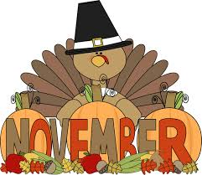
WEDNESDAY | First course: Macarrones gratinados/ Gratin Pasta  Second Course: Merluza en salsa verde/ Green sauce Hake  Dessert: Fruit or Dairy/Fruta o lacteo | First course: Judías Pintas/Pinto Beans  Second Course: Salmón al horno/ Cooked salmon  Dessert: Fruit or Dairy/Fruta o lacteo | First course: Paella de marisco/Seafood paella  Second Course: Rabas/Fried squids  Dessert: Fruit or Dairy/Fruta o lacteo | First course: Ensaladilla rusa/ Russian salad  Second Course: Dorada a ala espalda./ Grilled Gilt head  Dessert: Fruit or Dairy/Fruta o lacteo
THURSDAY | First course: Lentejas con verduras/ Stewed lentils  SecondCourse: Lomo adobado a la plancha/ grilled marinated pork loin  Dessert: Fruit or Dairy/Fruta o lacteo | First course: Crema de verdura/Vegetables cream  Second Course: Pollo asado/Roasted chicken  Dessert: Fruit or Dairy/Fruta o lacteo | First course: Crema De Calabacín/ Zuchinni’s cream  Second Course: Pastel de carne./ Meat pie  Dessert: Fruit or Dairy/Fruta o lacteo | 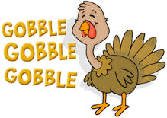  First course: Patatas asadas/Grilled potatoes  Second Course: pavo asado/Roasted Turkey.  Dessert: Pumpkin pie.
FRIDAY | First course: Ensalada de patata/ Potatoe salad.  Second Course: Bacaladitos./fried codfish  Dessert: Fruit or Dairy/Fruta o lacteo | First course: Marmitako/ Stewed tuna and potatoes.  SecondCourse: Croquetas caseras/Homemade croquettes.  Dessert: Fruit or Dairy/Fruta o lacteo | First course: Molinos mareados/ Dizzy mills  Second Course: Delicias de Dulcinea/ Dulcinea’s delights  Dessert: Special Quijote’s Dessert

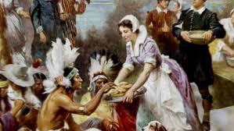

FIND GREAT SEASONAL RECIPES AND IDEAS CLICK ON…
http://www.bbc.co.uk/food/seasons/november
http://www.bbc.co.uk/food/occasions/thanksgiving
http://www.bbcgoodfood.com/seasonal-calendar/month/november
https://en.wikipedia.org/wiki/Thanksgiving
http://www.marthastewart.com/856379/thanksgivingmenus/@center/276949/everything-thanksgiving
November is the “Harvest” and Thanksgiving month SO… WHY DO’T YOU TRY THIS DELICIOUS AND HEALTHY menu with your family??????
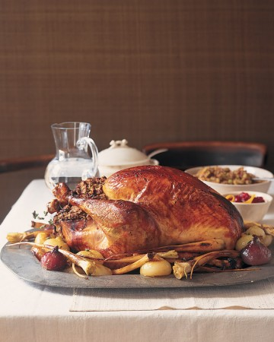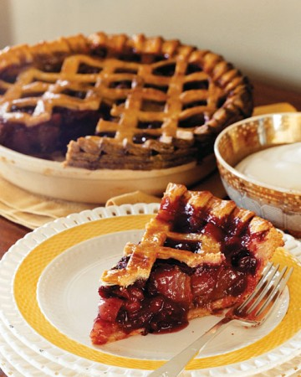Traditional Thanksgiving dinner
In many families, there's no diverging from the classic: turkey with all the trimmings. With many of these beloved foods gracing the table just once a year, favorites inevitably emerge from the family kitchen for generations.
Main course: Roast Turkey
Side dishes
Classic Light Rolls
Apple-Butternut Squash Soup
Mashed Potatoes
Brussels Sprouts with Lemon and Walnuts
Maple-Glazed Sweet Potatoes
Cranberry-Ginger Jelly
Dessert
Pumpkin Pie
Old-Fashioned Apple Pie

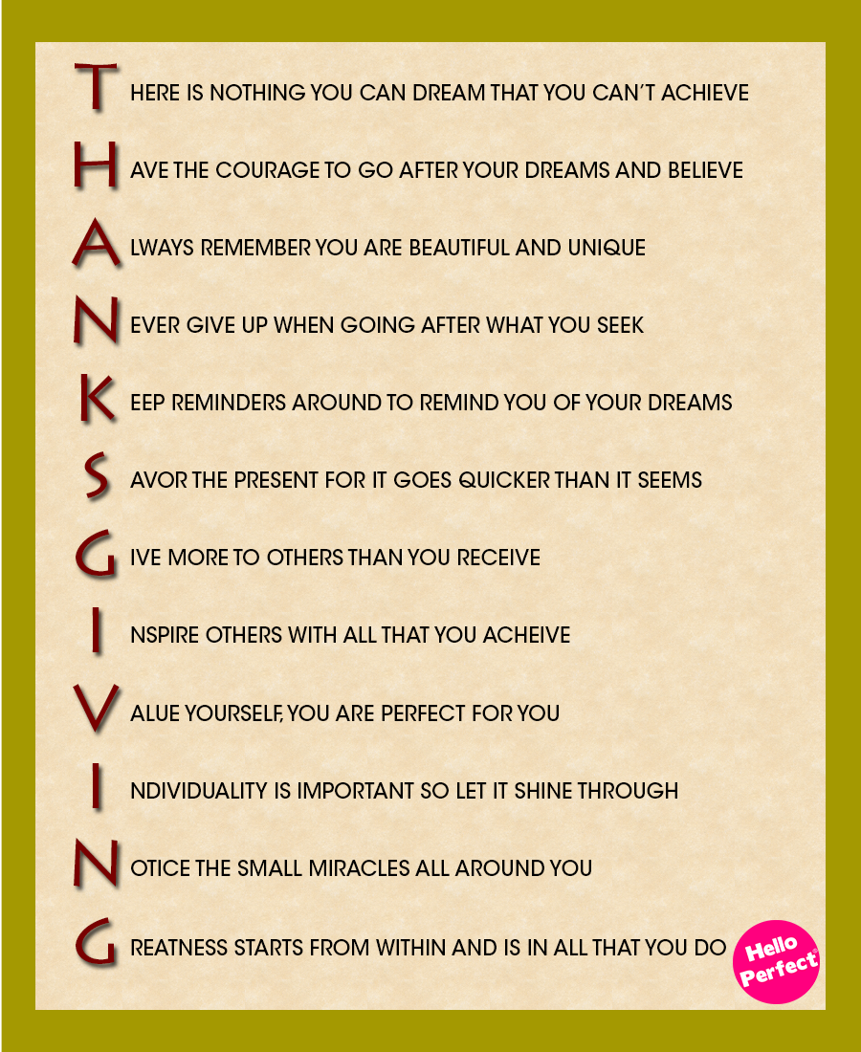

TIPS FOR DINNERS
Lunch | Dinner
Pasta/Rice + Meat | Vegetables + Fish
Pasta/Rice + Fish | Vegetables + Eggs
Pasta/Rice + Eggs | Vegetables + Meat
Vegetables + Meat | Pasta/Rice + Fish
Vegetables + Fish | Pasta/Rice + Eggs
Vegetables + Eggs | Pasta/Rice + Meat
Legumes + Meat | Vegetables + Fish
Legumes + Fish | Vegetables + Eggs
Legumes + Eggs | Vegetables + Meat
Fruit | Dairy milk
Dairy milk | Fruit

